Dr. Charoula Stathopoulou (Assistant Professor in Mathematics and Didactics of Mathematics, University of Thessaly)
Ms Kotarinou Panayiota (Phd student, Ba (hon), QTS)
Mr Gkoufas Konstantinos (Mphil, MEd, Ba (Hon), QTS)

Integrating 10th grade curriculum through Drama: the Greek traditional practice of Xysta.

Abstract

In this paper we present the design and implementation of a cross-curriculum project that was carried out among grade 10 students in a public school in Athens. The project concerned the tradition of designing Xysta, which are geometric patterns on façades of village houses in the island on Chios. Drama in Education techniques were used as a unifying framework, introducing notions from diverse cognitive areas. The objective of the project was both research and instruction. Regarding research, the main purpose was exploring the way Drama in Education techniques affect the instructional classroom practices. Regarding instruction, the main objective was teaching and retention of the geometrical notions as well as the use of the Greek language in special circumstances. Our research offered considerable evidence of the effectiveness of the use of Drama techniques in combination with Interdisciplinarity as an alternative approach in the teaching of different subjects of the curriculum.

- Introduction
Research has shown that the teaching and learning process becomes more effective when students have the opportunity to see connections across disciplines instead of studying the subject as an isolated component (Cheek, 1992). The fact that no problem from the real life is a matter of an isolated treatment and also the fact that the creation of interconnections amongst subject areas could be a motivational tool for students to study a specific area meaningfully, provide excellent grounds for interdisciplinary perspectives.
The curricular framework that was in effect in Greece, at the time the research was conducted, emphasized the importance of cross-curricular work as an innovative practice aiming towards synthesis and cohesion amongst subject areas. Although the development of such projects was not compulsory in upper secondary school at the time research conducted, our previous experience in developing interdisciplinary projects through Drama in Education techniques, encouraged us to continue.
The overall topic of the project presented in this paper was the traditional designing practice of Xysta. Xysta are patterns, mostly geometrical ones, which are constructed on house facades by traditional craftsmen in the village of Pyrgi in the island of Chios. The pragmatological material that was used as the basis for this project was the product of an ethnographical research, conducted a few years ago by the one of the authors. Specifically, students had access to a PowerPoint presentation that was prepared for a conference as well as to a WebQuest focused on this tradition.
Our methodological approach was qualitative. The fieldwork was carried out in an upper secondary public school in an underdeveloped district of Athens. All students of the 10th grade took part in the project as well as their teachers of mathematics, Greek language, English and computer science in specific roles that will be analyzed later. The main cognitive object was to discuss mathematical notions, as symmetry and patterns, through the use of informative speech (Greek language). For the preparation of the project a paper regarding Xysta was read and analyzed in the English class. Selected information was presented through a PowerPoint presentation in the computer science class. In order to unify these different subjects dealing with the concept of Xysta we used techniques of Drama in Education. A TV show was organized with students in roles, while for its purposes students used the technique of reportage, too.
In this paper we describe the dynamics that emerged through the use of Drama in Education and the interdisciplinary approach in classroom practices and how it affected the students, teachers, and their relation as well as cognitive issues. Below we shortly speak about Interdisciplinarity and Drama in Education, mostly in the context of the teaching and learning of mathematics, and then we present the design and the implementation of the project.

- Interdisciplinarity

Mayer (2005) notices: one of the biggest problems in all formal learning is keeping students motivated enough to stick with the learning process to the end of e.g. a lesson, course, semester, […]. Research has shown that interdisciplinary and cross-curricular teaching can increase students' motivation for learning as well as their level of engagement and thus provide conditions for effective learning (Thaiss, 1986).
In interdisciplinary teaching, educators apply methods and language from more than one academic discipline to examine a theme, issue, question, problem, topic, or experience. Interdisciplinary methods work to create connections between traditionally discrete disciplines such as mathematics, the sciences, social studies or history, and English language arts (Coffey, 2011). Interdisciplinary/cross-curricular teaching provides a meaningful way in which students can use knowledge learned in one context as a knowledge base in other contexts in and out of school (Collins et. al, 1989).
As Jacobs (1989) notices, the fragmentation of learning in a traditional school does not reflect real life where we encounter complex problems and situations, gather data from various sources, and create solutions. She introduces Chapter 1 of her book “Interdisciplinary Curriculum” with a quote from a 2nd grader describing mathematics as “something you do in the morning”. The way school curricula are formed make students think of the subject areas as separated bodies of knowledge without realizing the relationship among them. Typically, even though students learn the basic information in core subject areas, they are not able to apply their knowledge effectively in thinking and reasoning (Applebee et al., 1989). The curricula presented in textbooks are neither well timed nor relevant to students’ lives (Coffey, 2011 p.1). The interdisciplinary model of teaching enables students to see the links between various subjects and consequently to see the knowledge in a unified way, making their school experience more compatible with their real life.
Barton and Smith (2000) explain that interdisciplinary units enable teachers to use classroom time more efficiently and address content in depth, while giving students the opportunity to see the relationship between content areas and engage in authentic tasks. As Sriraman (2009, p.9) notices, human beings are by definition ‘‘interdisciplinary’’, we are complex neurobiological organisms capable of juggling a wide array of tasks that intertwine the physical, psychological, interpersonal, intuitional, intellectual, cultural and spiritual dimensions of being. Yet, schooling and institutional practices utilize only a fraction of our capabilities with the goal of reducing us to functional specialists who propagate the existing status quos.
As the contemporary society becomes more and more complex, one needs to approach education research and mathematics education research in particular through different angles. As such there is a need to consider theoretical approaches and to ask complex and systematic questions, as well as to encourage viewing research as rooted in collaborative practices. To this end, Interdisciplinarity as a research perspective seems to be working for both research and teaching purposes. ‘Interdisciplinarity is increasingly viewed as a necessary ingredient in the training of future oriented 21st century disciplines that rely on both analytic and synthetic abilities across disciplines’ (Shriraman, 2009: v). Thus, an interdisciplinary approach to teaching and learning is key for any successful educational enterprise which aims to prepare future generations to deal with the increasing complexity and interconnectivity of our world (Freiman and Shriraman, 2010).
The use of Drama in Education techniques seems to be a suitable framework that offers ways for integrating varied disciplinary areas of curriculum. It can also be used as a creative way for the students to reflect on broader learning issues (emotional, cognitive, social, and political) mostly because of its experiential dimension.

- Drama in Education

Drama in Education (DiE) can be a highly structured pedagogical procedure utilizing specific rituals and techniques of dramatic art aiming to focus participants’ attention towards the experience and not on the final product (Alkistis, 2000). Potentially, it constitutes a teaching approach that can embrace collaborative, active learning through experience, while giving participants the opportunity to develop acceptance, understanding, creativity, curiosity, self-consciousness and self-esteem (Alkistis, 1998, Wagner, 1999, Wooland, 1999).
Drama encourages the development of social skills, including listening and response, empathizing, leadership, evaluation of own work and the work of others, reflection, self discipline, willingness to take risks, questioning and challenging, self-confidence and the awareness of the needs of others. The students become actors and the audience. This allows them to participate in the learning process through the acting as well as through the development of critical discussion and questions as the members of the audience (Neelands, 2008). Furthermore, Drama in Education grants us, through the creation of an imaginary world the background for teaching of different subjects of the syllabus (Andersen, 2004).
The main advantages of using drama concern the classroom culture, the teacher-students relationship as well as the cognitive and metacognitive domain. Regarding the teaching and learning of mathematics, although relatively limited, the research of the influence of introducing drama in the teaching process is very encouraging in students’ understanding and retention of mathematical notions (Saab, 1987, Omniewski, 1999, Fleming et al., 2004, Duatepe, 2004, Kotarinou and Stathopoulou, 2008) and in creating positive impact in their attitudes towards mathematics (Kayhan, 2008, Duatepe, 2004).
Specific techniques such as the ‘as-if’ approach create the context for teaching a concept, an idea or an event and offer opportunities for exploring mathematics in a variety of historical, social and cultural contexts (Kotarinou et al., 2010, Lawrence, 2000, Gensrick, 1992, Pennington and Faux, 1999, Holden, 2002, Gadanidis et al., 2005). Participation in activities of this type familiarizes children with a holistic handling of issues, empowers them to justify their point of view, practices their mental flexibility and alertness, and enhances their ability of self-criticism and their conciliatoriness.
In an earlier study, Chronaki (1990) interviewed experienced mathematics and drama teachers who were involved in either long or short-term cross-curriculum projects aiming at teaching mathematics and drama techniques. All of them mentioned that, despite the time and curriculum constrains, drama techniques provided the means to motivate children to active participation in mathematics problem solving. Inspired by the work of Heathcote (1984), Way (1967) and Bousquet (1986) and confronted with the rigid structure of the mathematics curriculum reform in the early 1980s, as well as, specific needs for mathematical numeracy stressed out by the Cockroft report, some mathematics and drama teachers in the UK of the late 1980s turned towards exploring innovative cross-curricular connections in specific cross-departmental co-operations. Their motivation was aimed at battling children’s de-motivation and indifference towards the abstract mathematics curriculum that stressed uniformity and ceased leave space for creative and critical thinking (for more details see Chronaki, 1990).
In this paper we used drama education techniques, a TV show in particular, in order to discuss the traditional designing practice of Xysta in a classroom environment.

- Design and implementation of the research
  - Methodology
The realization of the complexity of the teaching and learning procedure was the basis for choosing the qualitative approach in our reassert. As Presmeg (2009, p.134) noticed, the current trend in the research in the teaching of mathematics focuses on the integrated nature of all the aspects of being human that play out in the learning of mathematics.
In our study we were mostly interested to explore the way participants think and act, the relationships that formed between the participants, the way culture of the classroom changed. We consider that a framework of positivist orientation research does not provide important information. Since we aimed at studying the results of teaching in the group of students as well as the procedure, the discourse and the communication that ensued, we chose naturalistic orientation research, according to Lincoln and Guba’s (1985, p. 38) categorization. This kind of research is characterized by the fact that all entities are in a state of mutual simultaneous shaping so that it is impossible to distinguish the cause from the effect.
In particular, we modeled our experiment on the teaching experiment for the design of the activities in combination with ethnographic techniques for the observation and collection of data (Chronaki, 2008). One of the authors participated in all phases of the research either as a participant or as an observing participant. She kept ethnographical notes, and the ethnographic material was supplemented by interviews with the students and teachers and video of parts of the entire procedure.
  - Setting

This project was carried out in a group of grade 10 students in the 2nd High School of Ilion in Greece, a deprived area of Athens. The research was conducted during the academic year 2009-10. Four teachers collaborated in the project: a mathematician (one of the authors), a linguistic (co-author), an English teacher, an arts teacher and a computer science teacher. The class did not have any previews experience of either working interdisciplinary or through drama in education techniques. The involved educators, except of the mathematician, had no experience in teaching in this kind of framework. In the past she collaborated on designing projects as: “An Amazing Story – The Measurement of the Earth by Eratosthenes” (Kotarinou et al., 2008), “Establishing the ‘Meter’ as citizens of French National Assembly during French revolution’’ (Kotarinou et al., 2011) “Archimedes: The Sand Reckoner” (Kotarinou and Stathopoulou, 2010).

The project was conducted in 8 hours in the Greek language lesson, 3 hours in the mathematics lesson, 1 hour in the English language lesson 3 in Arts class and 3 in ICT class.
Τhe study was based on the ethnographical research for studding Xysta at Pyrgi village on the island of Chios, that was conducted by the third author a few years ago. The objective of this study was the exploration of the relation between Xysta and the community and the exploration of the informal mathematical notions that are hidden in this practice. In the following unit we briefly present this research.
  - Xysta: connections with the community and the incorporated mathematical ideas

Xysta is a kind of a fresco that appears in the village Pyrgi of Chios, one of the island’s medieval villages. Although there are a few Xysta -covered houses in other villages, the ones in Pyrgi are considered to be the tradition of this place. Xysta are patterns, mostly geometrical forms, constructed by traditional craftsmen on house facades in the village.
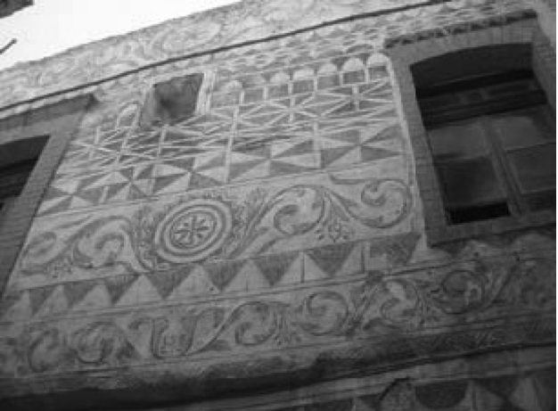
In order to create Xysta one has to use the following technique. Initially craftsmen plaster the façade of the house. One layer of plaster is used to smoothen the surface and the optional second layer is the base for Xysta. When the material is still fresh, a layer of whitewash is put on top. After that craftsmen divide the wet surface in zones and in each zone they design patterns they consider appropriate. The patterns are created by scratching off the whitewash as a result of the colour difference between the whitewash and the plaster.
The main materials that were used during the above procedure, depending on the age of Xysta, were different kind of sand, mortar, whitewash and cement. The tools that the traditional craftsmen use are a lath, a compass with two points (both with the same use), and a fork. The use of the lath serves two purposes: it separates the wall’s surface in zones and constructs straight lines. The divider is used for the construction of circular figures and the fork for scratching some areas of the figures in a way that one area is dark (the scratched one) and the other – white. The particular pattern is repeated until the entire area is covered.
This tradition is very important for the local community, particularly for the indigenous identity. The fact that Xysta constitute a cultural practice, as well as the fact that they are based on simple geometrical ideas makes them an interesting subject for an ethnomathematic and linguistic studies (Stathopoulou, 2007).

  - Design and implementation
The design of the project resulted from the collaboration of two of the authors—both mathematicians. The theme of Xysta was chosen due to it’s interesting mathematical concepts hidden in the geometric patterns and because it provides an opportunity to familiarize students with the fact that mathematics is connected to cultural factors: it isn’t a culture free cognition. One of the mathematicians was trained in Drama in Education techniqhes and was the only member of the project team with prior experience.
In order to motivate students, we planned a TV show about Xysta. Students were given the opportunity to decide the title of the show as well as their representatives in it. The title the students came up with was: “Discovering xysta and their mathematics”. A student was selected to be the host of the show, another the reporter and some other students got the role of folklorists, architects, craftsmen and mathematicians, as members of the show’s panel. The task of the reporter was to take interviews from teachers and students of the school regarding Xysta. The rest of the students were going to be the audience, who listened and asked questions to the specialists.
The students collected information and prepared their material in order to support their role at the panel contributing to different lessons as follows.
In Literacy class: The main cognitive objective regarding the specific class was to investigate cultural and historical implications of Greek architecture through language and share a presentation and performance with students of other classes. Students were taught during 4 lessons the strategies of Informative Speech and the definition and characterization of Greek language and its dialects. According to the national curriculum the sections on Informative Speech covered were the following:
- Purposes of informative speaking
- Major types of informative speeches
- Strategies for selecting a topic
- Framing a thesis statement
- Researching your topic
- Structuring an informative speech
- Outlining an informative speech
- Delivering an informative speech
Defining language and dialect in particular was yet another criterion for a successful delivery of such interdisciplinary project as its relation to Greek architecture in Greek peasantry rendered understanding of dialect and accent essential.
The students, having familiarized themselves with the relevant theory framed a thesis statement alongside the teacher and began to research on their topic (Xysta). They had to find information about Pyrgi village, as well as to define the term Xysta and search for different kinds of them. Working in groups, they located relevant resources on Xysta in the library and cited those accordingly in their speech; they consulted books, journals, newspapers and certain web sites.
The students’ internet research inquiries were carried out through the Webquest in http://didaktikop.blogspot.com/ created specifically for such purposes (Stathopoulou & Kotarinou, 2008).
Students were randomly divided in groups, with every group having a different role: the role of Historians/ folklorists, of Architects and of craftsmen. Every group had to carry out the relevant tasks in the Webquest and prepare a PowerPoint Presentation supporting their role in the TV show.
The students in the role of Historians/ folklorists had to gather information regarding the village’s history and the history of Xysta. More precisely, they had to determine the time of the first appearance of Xysta.
The ‘Architects’ group had to gather information regarding houses of Pyrgi architecture and explore if and how the architecture of the houses is related to the tradition of Xysta.
The ‘craftsmen’ group had to explore the way that traditional craftsmen constructed Xysta and find out the tools they used. The students also had to study a paper regarding the construction of Xysta and the informal knowledge that is incorporated to them.
Some students as reporters interviewed teachers and others students about xysta, and used this footage during the TV show.
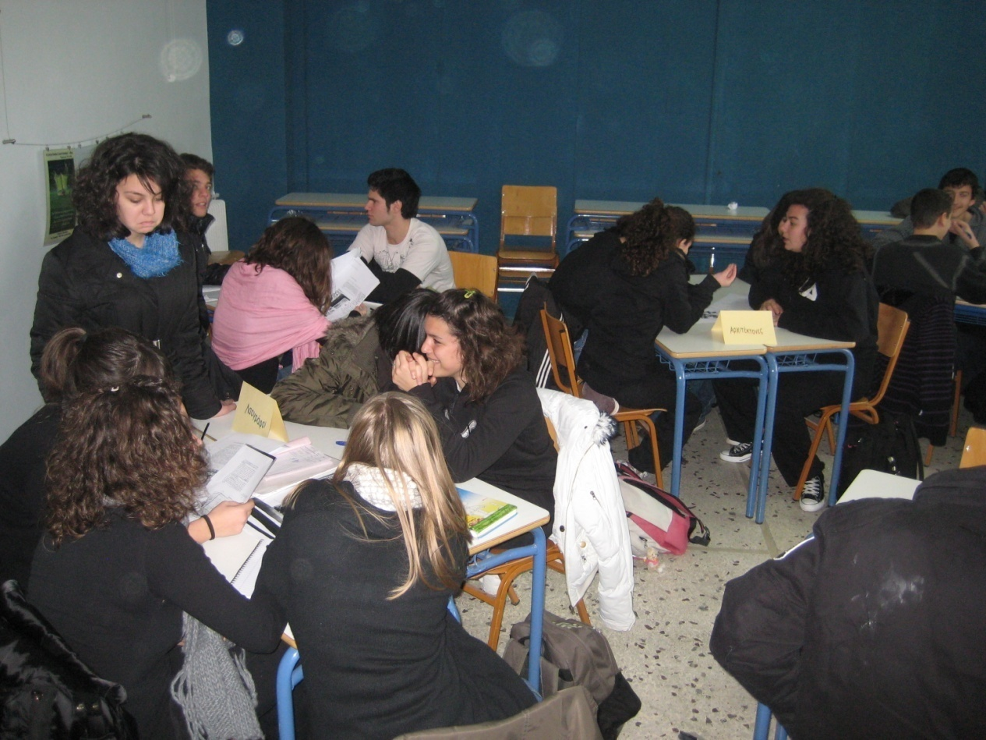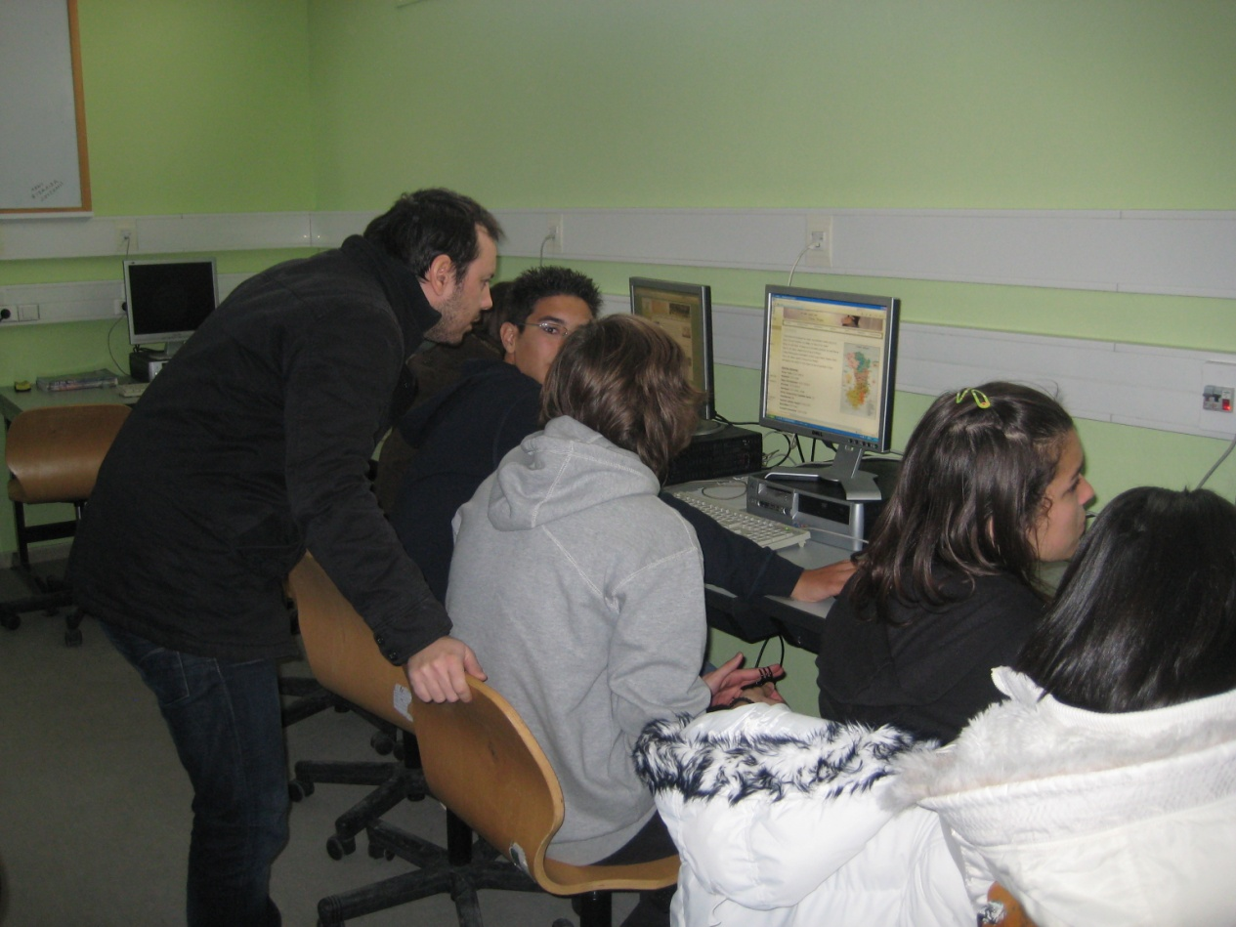
Studying the relevant recourses Working through WebQuest

In English language class session: Students attended a PowerPoint presentation on Xysta in English language. A discussion was held about geometrical tools and their comparison with craftsmen’s tools. Finally, there was a discussion about Ethnomathematics and the designing activity which, according to Bishop’s categorization (1988), is one of the six mathematical universal activities (: counting, measuring, locating, designing, playing, and explaining).

In Geometry class: All Xysta figures appear strongly symmetrical. Therefore, investigating mathematical ideas that are incorporated in Xysta was considered as a good opportunity for a revision of the notion of symmetry that had been taught two months prior to the project.
Students worked in pairs, in ICT lab and did all the mathematical tasks in the aforementioned WebQuest such as defining in a figure the motif, the sorts of symmetry, the axes or centers of symmetry. Two students from the whole class were chosen to represent the class in the panel of the TV show as mathematicians.

In ICT class: The students that had chosen the optional ICT class were taught how to do a PowerPoint presentation. Demonstrating this newly taught skill, every team (the folklorists, the architects, the craftsmen) prepared their own PPts on Xysta.

In arts class: The students following the arts class painted their own Xysta
Here there are a few photos of students’ paintings.
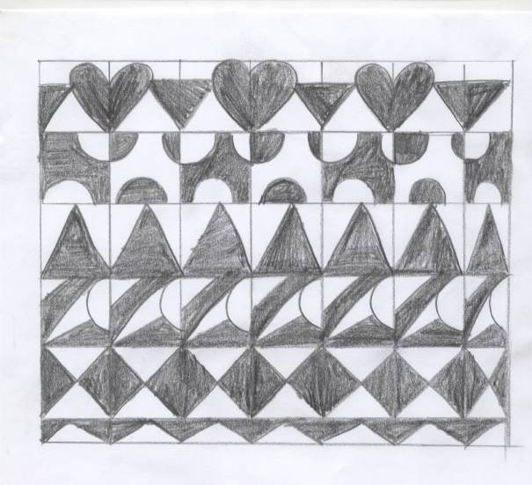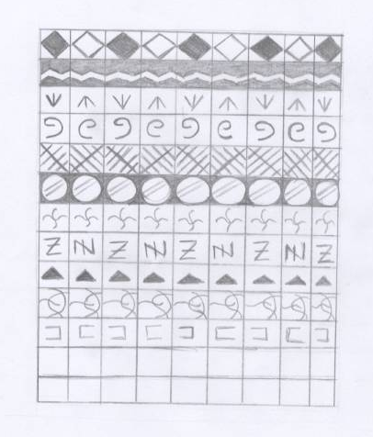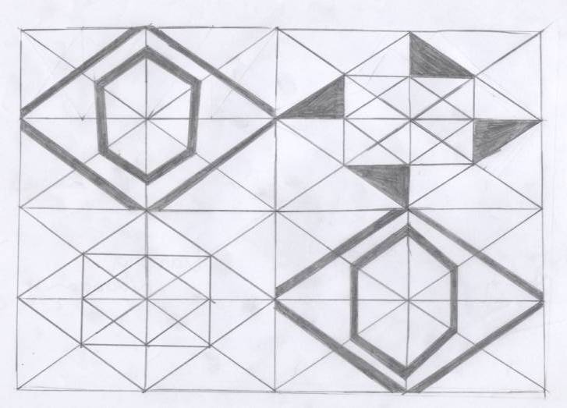
The panel for xysta
The whole drama activity took place in the school theatre and was attended by the students from another class.
As an opening act, the aforementioned interviews of students and teachers were aired, which led to the conclusion that general knowledge around Xysta was limited and justified the decision to stage that show.
The host of the round table discussion introduced to the audience the participating members of the panel and then one by one the speakers gave short lectures about xysta from their point of view as folklorists, architects, craftsmen and Mathematicians. At the same time they presented the slides from digital presentations they had prepared in their ICT lesson; so that the audience could be informed about this traditional practice.
The folklorists were the first ones to elaborate, explaining what the art of Xysta is and presenting their history –the first appearance, the source of influence, the needs that led to their creation- as well as the history of the village. Concludingly, they presented Xysta patterns, their theme as well as their connection to the life in the village.
The architects informed the audience on the architecture of the houses in Pyrgi and the craftsmen on the way the Xysta were made by traditional craftsmen. Mathematicians referred to mathematical concepts such as symmetry, which recurs in the drawings. During their attempt to connect the Xysta with Mathematics, they referred to Ethnomathematics –underlining the relation between Mathematics and culture- and pointed out the six universal mathematical activities: counting, locating, measuring, designing, playing, explaining (Bishop, 1988) and, finally, the concept of symmetry.
Finally, a Q&A session was followed by the assessment (via assessment sheets) of the speakers by the students who were part of the audience. The teacher kept notes on how they transfered their literacy skills from theory to practice and noticed that during the presentation students used all the linguistic patterns they had been taught along with informative speech strategies. The majority of students responded really well as they used appropriately all the linguistic techniques they have been taught which along the body language and audience adaptation created a strong drama activity.
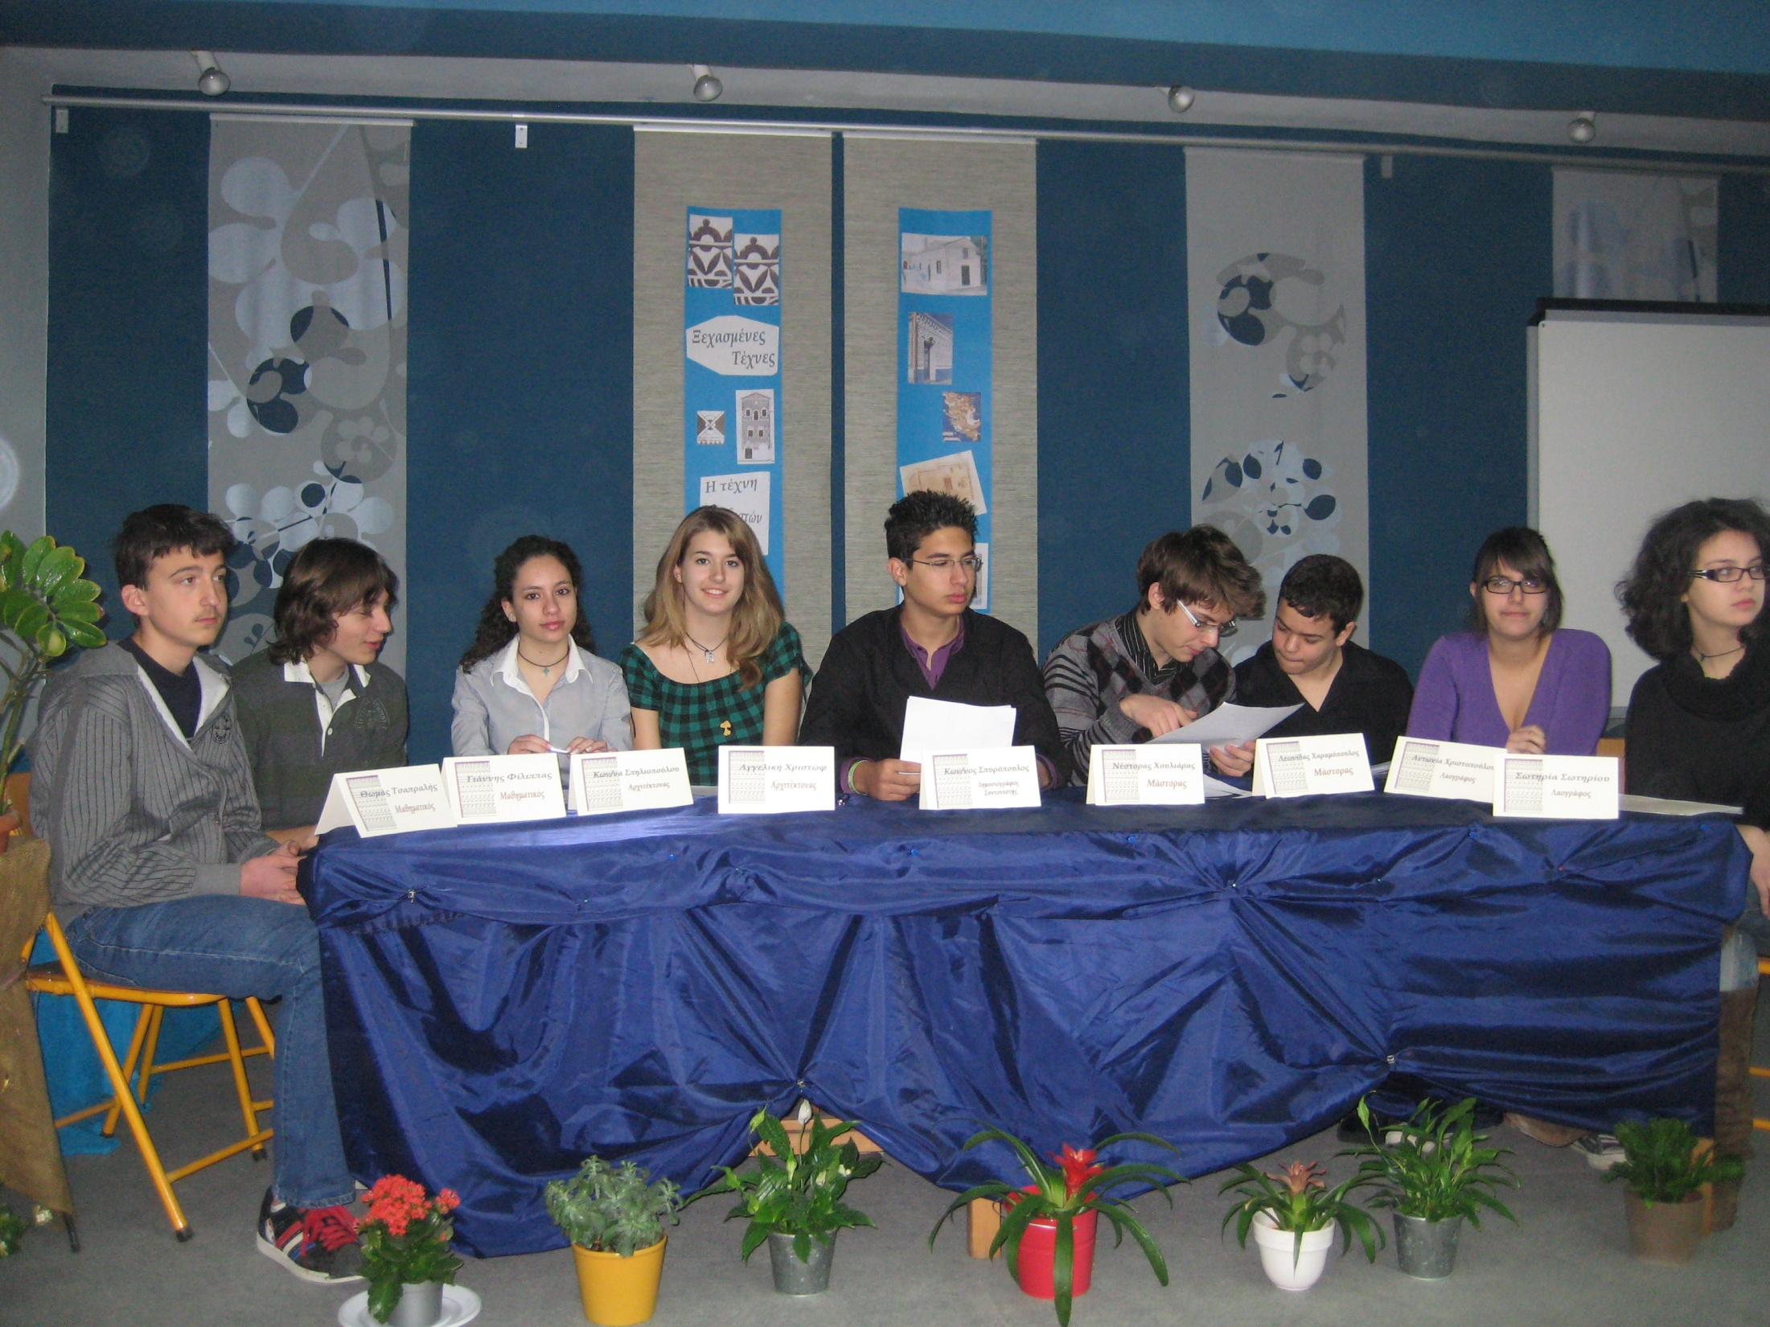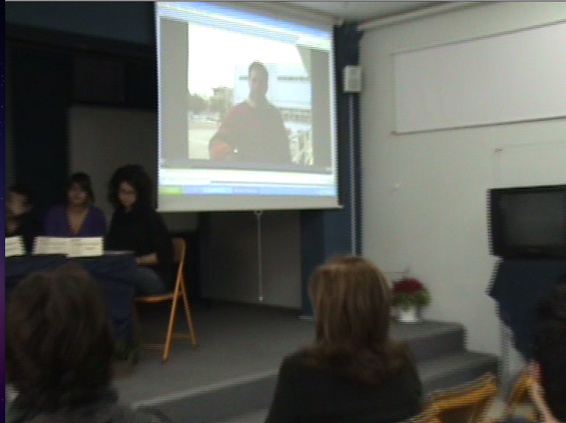
The panel The reportage during TV show
  - Reflection on the Show Activity
Next teaching period students reflected and discussed their experience of the whole project. We finished the reflection with an enactment of the different sorts of symmetry.
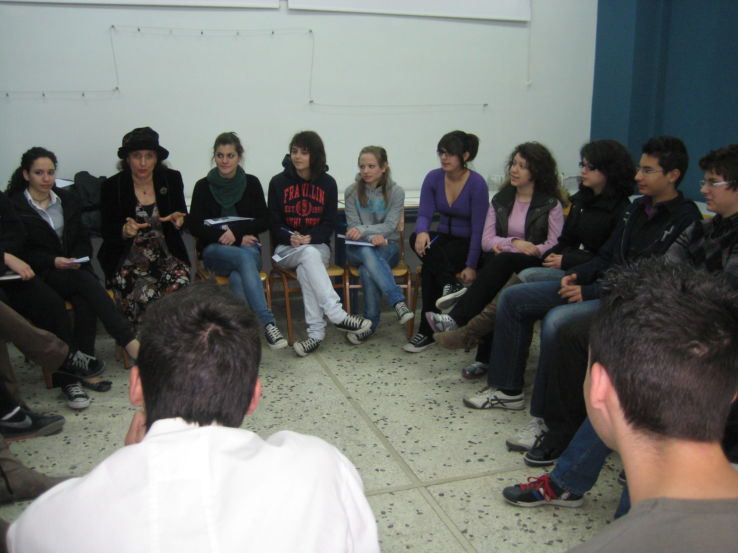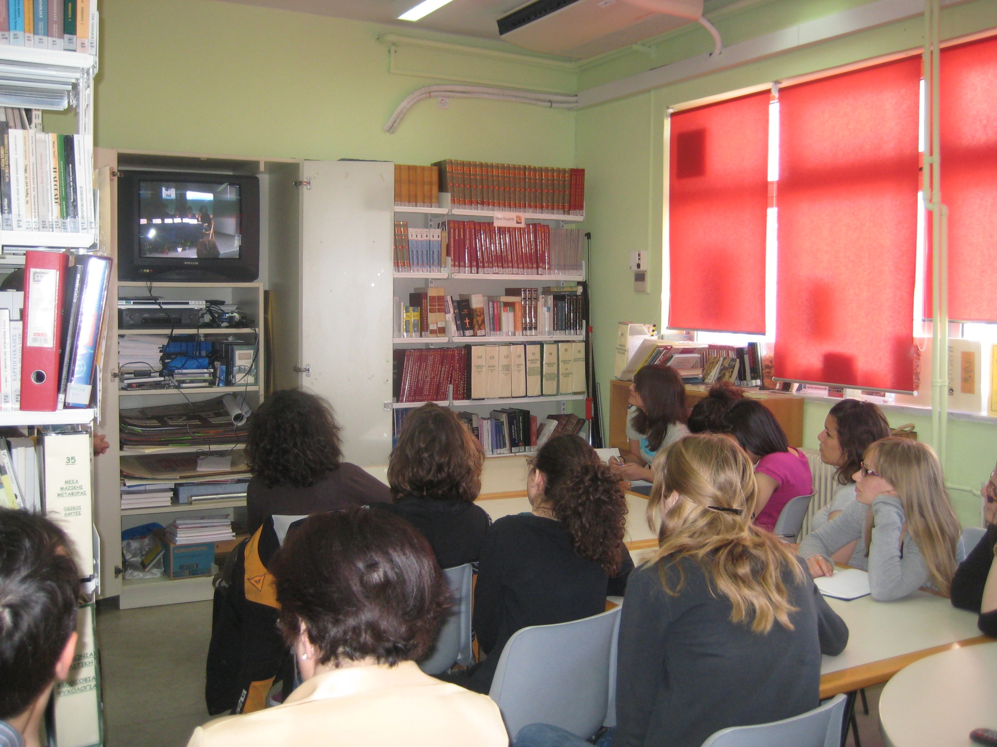
Sitting in a circle to reflect Watching their round table discussion

A month later...

In Greek language and literacy class: The head of the school, coach of the school debate club, along with the students watched the video of the performance of the round-table about Xysta and discussed with them the art of ‘persuasion’ and argumentation. The students talked about their participation in this round-table.

In Maths lesson: Students had to think of how they consider ‘persuasion’ in Maths in contrast to persuasive language in other subjects. After discussing this subject, the role of proof in Mathematics was clarified. Then students worked in groups on the mathematical term Reductio ad absurdum (proof by contradiction) and performed some examples of the use of this kind of proof e.g. by Galileo in physics and by solicitors in court.

PRELIMINARY ANALYSIS: questionnaires and videotapes
A preliminary analysis of the interviews and the videotaped discussion after the performance permitted us to stress a number of axes related to processes of knowledge construction and values building such as: cooperation, changing stereotypic images of mathematics, experiential learning. Each of these are briefly analyse below:

Cooperation: Students stressed in their interviews the opportunities for collaboration that Drama offered as well as the satisfaction they felt from the specific collaboration.
- ‘In my opinion, it was a very nice experience, because we learned how to work with our classmates, we came closer with them’.
-‘The best moment was when we were divided in groups, because we learned how to cooperate’.
-‘I enjoyed group work because we could ask the classmates next to us, if we didn’t understand something’.

Experiential learning: Students appreciated the learning experience of learning through Drama. Since drama links real life and mathematics, the lessons became scientifically and personally meaningful to the students and the comprehension of concepts was facilitated. Furthermore, it was stated that drama-based instruction made learning geometry notions more meaningful, easy, permanent, and visual.
- ‘It was something that we will remember whereas we won’t remember a common lesson’.
-‘We don’t learn many things from our ordinary evaluation sheets in school. We put different things in them simply to have more material, while now we had to understand all these things’.
-‘…the round table motivated us to do a better job. The more we worked, the better the results would be.’
-‘We gave life in some class periods’.
- ‘I liked the idea that I was on stage and we were talking like specialists.’
-‘It was something like play. It was nice.’
-‘We have learned many things through acting.’
-‘We experienced something we have never lived before.’

Changing the image of the nature of Mathematics: Students realised that mathematics are present –even though not always overtly- in several contexts and that they are a constitutive element of culture. This knowledge, all in all, led to a broader perception of the nature of mathematics.
-‘During the whole process, the connection of Geometry and Literacy with everyday life and art was emerged.’
-‘...many times (mathematics) there is a simple knowledge that is useful in our everyday life. There is no need to be a scientist to use mathematics, it isn’t so difficult.’
-‘…although we use symmetry in our lives, we have learned symmetry only as a procedure.’
- ‘We saw Geometry in a different way. It’s something new to us, because here (in every day class) we do Geometry simply for solving, for estimating angles, finding parallels and thing like these.’
-‘... school does not give children the opportunity to understand that mathematics are useful in something.’

5. Some conclusionary remarks

The objectives of this project were twofold. Students were expected to work cooperatively, familiarize themselves with specific geometrical concepts such as symmetry, patterns, geometrical construction and realise that mathematics can appear in several contexts. Meanwhile, the development of their skills both in oral and written speech proved out to be of equal significance.
It is our conviction that our project objectives were met to a great degree. Through cooperation and experiential activities, students comprehended mathematical concepts and integrated them in their communication. All the research made by students for the realisation of drama (the T.V. round- table discussion), as is the case with drama per se, gave them the opportunity to familiarize themselves with the social context in which the art of Xysta was developed and understand that science, society and culture are closely interwoven.
The materialization of the project was also directly connected with a change of the class ‘culture’. From our observations, this change had a lot to do with the combined presence of teachers of different subjects in the classroom, the simultaneous realization of interdisciplinary activities and the necessity for teamwork. Through a variety of activities, a concerted effort was made to change the established role of the teacher, from the one of the authority who transfers established knowledge to that of the facilitator and to establish cooperation among both educators and pupils.
It was found that the program produced significant positive effects on student motivation and engagement in learning, and notable changes in classroom practices.
However, although maths teachers may consider positively their involvement with dramatic techniques in the context of cross-curriculum co-operations, such attempts seem to face difficulties due to given time and space constraints created by a rigid demand for curricular content coverage and national assessments. They also hesitate to use drama because they have never been trained in such techniques or they can not accept drama as suitable means to mathematics teaching. In Greece the difficulties are greater due to the absence of drama teachers in high school able to cooperate with maths teachers in interdisciplinary projects.
The outcome of our project analysis, offers considerable evidence of the effectiveness of even simple Drama techniques as an alternative approach in the teaching of different subjects of the curriculum. The simple form of role play could be a useful starting point for teachers of maths and other subjects, while more experienced teachers could address the theme of Xysta in drama in a way that uses more tension – for example in which the specialist challenge a town council who have proposed to cover up the patterns in order to modernize the town to attract more tourists or an imaginative re-enactment of how Xysta was first developed/discovered. Τhe whole project presented in the paper could be extended by more experienced teachers or with the help of Drama teachers, to a more fully fledged “mantle of the expert” approach.
Our teaching experiment pointed out Drama’s effectiveness in integrating different subjects of the curriculum.
Drama can undoubtedly build the bridges to connect disciplines.

BIBLIOGRAPHY

Alkistis Κ. (2000). Drama in Education, Ellinika Grammata, Athens.

Alkistis Κ. (1998). The book of Dramatization, Hellinika Grammata, Athens.
Andersen, C., (2004). Learning in "As-If" Worlds: Cognition in Drama in Education, Theory Into Practice , 43( 4), pp. 281-28.
Applebee, A.N., Langer, J.A., & Mullis, I.V. (1989). Crossroads in American education: A summary of findings: Educational Testing Service. Princeton, NJ.
Barton, K.C. & Smith, L.A. (September 2000). Themes or motifs? Aiming for coherence through interdisciplinary outlines. The Reading Teacher, 54(1), 54– 63.
Bishop, A.J. (1988). Mathematical Enculturation: A Cultural Perspective in Mathematics Education, D. Reidel Publishing Company, Dordrecht.
Bousquet, M. (1986). What makes us play? What makes us learn? Prospects, 16 (4), pp. 465-474.
Cheek, D.W. (1992). Thinking constructively about science, technology and society education. Albany, NY: SUNY Press.
Chronaki, A. (1990). An investigation of the potentiality of using drama in the teaching of mathematics in secondary school, Unpublished Master Dissertation, University of Bath.
Chronaki, A. (2008). The teaching experiment. Studying learning and teaching process in B. Svolopoulos. (Ed.), Connection of educational research and practice, Athens: Atrapos
Coffey, H.(2011). Iterdisciplinary teaching, retrieved from internet 20-5-11, http://www.learnnc.org/lp/pages/5196.
Collins, A., Brown, J.S. & Newman, S.E. (1989). Cognitive apprenticeship: Teaching the craft of reading, writing and matematics. In L.B. Resnick (Ed.), Knowing, learning and instruction: Essays in honor of Robert Glaser (pp. 453-494). Hillsdale, NJ: Erlbaum.
Duatepe, A. (2004) Drama based instruction and Geometry, 10th International Congress on Mathematical Education, July 4-17 2004, Copenhagen, Denmark.
Fleming M., Merell C., Tymms P. (2004). The impact of Drama on pupils’ language, mathematics, and attitude in two primary schools, Research in Drama Education, 9(2).
Freiman, V., Sriraman, Bh., (2010), Introduction: Interdisciplinary Networks for better education in Mathematics, Science and the Arts, in Bh. Sriraman and V. Freiman, Interdisciplinarity for the 21st Century: Proceedings of the 3rd International Symposium on Mathematics and its Connections to Arts and Sciences, Moncton, Information Age Publishing, Inc.Charlotte, North Carolina.
Gadanidis, G., Gadanidis J., Huang, A. (2005). Using Humor to Gain Mathematical Insight, Mathematics Teaching in the Middle School, 10 (5), pp. 244-250, Jan 2005.
Gensrick, J. (1992). Drama in education : using "Mantle of the Expert" in the teaching of mathematics, Thesis (M.A.)--University of Wisconsin--Madison, 1992.
Heathcote, D. (1984). In L. Johnson and C. O’Neil (eds.) Dorothy Heathcote: Collected Writings on Education and Drama, Hutchinson.
Holden, J. (2002). What's This Got to Do with Maths? Education Review, 15 (2), pp. 35-40.
Jacobs, H. H. (1989). Interdisciplinary Curriculum: Design and Implementation. Alexandria, VA: Association for Supervision and Curriculum Development.
Kayhan H. C. (2008). Effect of Creative Drama as a teaching method on Attitudes towards Mathematics, proceedings of International congress of Drama/Theatre in Education, Ankara 21-23 November 2008, pp. 277-278.
Kelner, B. L. (1993). The creative classroom: A guide for using Creative Drama in the classroom PreK-6, Netherland, Heinemann.
Kotarinou, P., Stathopoulou, C., Chronaki, A. (2011). “Establishing the ‘Meter’ as citizens of French National Assembly during the French revolution’’, CERME 7, Rzeszow, Poland, 9-13 February 2011.
Kotarinou, P.; Chronaki, A.; Stathopoulou, Ch. (2010). Debating for ‘one measure for the world’: Sensitive pendulum or heavy earth? Mathematics Education and Society 6th International Conference, Berlin, Germany, 20-25 March, 2010.
Kotarinou P., Stathopoulou Ch., (2009) “The sand Reckoner”: an interdisciplinary project for integrating the teaching of different disciplines of High school curriculum’’, proceedings of 3^{d} Panhellenic Conference of the Union of Researchers in Didactics of Mathematics’’, Rhodes, 19-3 October 2009.
Kotarinou, P.; Stathopoulou Ch. (2008). Role –playing in Mathematics instruction, in proceedings of the 13th International congress of Drama/Theatre in Education, Ankara 21-23 November 2008, pp. 108-118.
Kotarinou P., Koutli D., Chrisanthaki-Apostolopoulou A. (2008). ‘‘Τhe impact of dramatic arts on the teaching of mathematics in the secondary education’’, proceedings of 6th Athens International Conference "Theatre & Education at Centre Stage" Hellenic Theatre/Drama& Education network , Athens 27-30, March 2008.
Lawrence, H. (2000). A Visit from Pythagoras--Using Costumes in the Classroom. Mathematics Teacher, 93(8,) pp 652-55, Nov. 2000.
Lincoln, Y. S., & Guba, E. G. (1985). Naturalistic inquiry. Beverly Hills, CA: Sage Publications, Inc.
Mayer, B. (2005). http://css.uni-graz.at/courses/TeLearn/SS05/Presentations/Game-Based_Learning.pdf, retrieved 11-11-2011.
McMaster, J. (1998). Doing Literature:using Drama to built literacy, The reading Teacher, 51(7), pp.574-84.
Neelands J., (2008). The Diversity of Drama Education; models and purposes, Theater and Education, 9, p. 58-66.
Neelands, J. (1984) Making Sense of Drama, Liverpool, Heinemann Educational press
Omniewski, R. (1999) The Effects of an Arts Infusion Approach on the Mathematics Achievement of Second-Grade Students, doctoral Dissertation, Kent State University, Dissertation Abstracts International, 60(05), 1389 A.
Papanikolaou, K, Grigoriadou, M., (2005), “Designing Webquests scenarios for teaching through multiple information for the structure, the operation and the improvement of the p.c., 3nd conference about new technologies in education, Syros, Greece.
Pennington, E & Faux, G. (1999). ‘‘…No Royal Road to Geometry’’ A ten lesson project in Mathematics, History & Drama for year5 or 6, Education Initiatives, Cardew Farm, Dalston, Carlisle.
Presmeg, N. (2009). Mathematics education research embracing arts and sciences, ZDM, 41(1-2), 131-141.
Saab, J. (1987). The effects of creative Drama methods on mathematics achievement, attitudes and creativity, Dissertation, Education D., West Virginia University.
Sriraman, Bh, Freiman, V. & Lirette-Pitre, N. (2009). Interdisciplinarity, Creativity and Learning: Mathematics with Literature, Paradoxes, History, Technology & Modeling. Information Age Publishing, Charlotte, NC. 248pp.
Sriraman, B. (2009). Interdisciplinarity in mathematics education: psychology, philosophy, aesthetics, modelling and curriculum. ZDM- The International Journal on Mathematics Education, vol.41, nos.1&2 , pp.1-3.
Stathopoulou, C., Kotarinou, P. (2008) Using Ethnomathematical ideas for designing an interdisciplinary project through a WebQuest, ICME-11, Monterrey (Mexico), June 30-July 4, 2008.
Stathopoulou, C. (2007) Traditional patterns in Pyrgi of Chios: Mathematics and Community, Nexus Network Journal, vol.9, no.1, pp.103-118.
Stathopoulou, C. (2006a), Exploring Informal mathematics of Craftsmen in the designing tradition of ‘xysta’ at Pyrgi of Chios, For the Learning of Mathematics 26, 3 (November, 2006), FLM Publishing Association, Edmonton, Alberta, Canada.
Stathopoulou, C. (2006b) Symmetry and gold section: two mathematical ideas incorporated in the tradition of Xysta (Pyrgi-Chios-Greece), open presentation in Third International Conference on Ethnomathematics , 12 – 16 February 2006 , Auckland, New Zealand.
Thaiss, C. (1986). Language across the curriculum in the elementary grades. Urbana, IL: ERIC Clearinghouse and Reading and Communication Skills and the National Council for Teaching English.
Wagner, B. (1999). Dorothy Heathcote. Drama as a Learning Medium, Heinemann, Portsmouth.
Way, B. (1967). Development through Drama. Longman.
Wooland B. (1999). Teaching Drama in the public school, Hellinika Grammata, Athens.

For example a role-playing debate concerning the choice of the ‘meter’ as a length measurement unit during the French revolution
WebQuests are guided activities that can be used to engage students in learning about specific topics using internet
Retrieved from: http://www.eduplace.com/rdg/res/literacy/interd1.html
The teaching experiment is a method to study the interrelated relationship between learning and teaching and is presented as an alternative suggestion to educational research, which is critically positioned towards positivist tradition. As a method it is developed through the need to study the very development process of learning and not merely the result (eg. The students’ performance).
Chios is a famous island not only in Greece but abroad as well: in the past due to the ancient epic poet Homer and nowadays because of the mastic.
A few years ago an ethnographic research was conducted by Stathopoulou, in order to be studied this traditional practice and to be connected with corresponding mathematical ideas that are hidden in Xysta. The first part of the fieldwork concerned both the observation of the patterns and the discussing with people of the area. The second part concerned the observation of two craftsmen who, for our research purposes, constructed a few patterns using this traditional practice. For more details see: (Stathopoulou, 2006a; 2007)
The time of hand they plaster the house’s façade depends on the way as well as on the material that was used for the wall’s construction. The original Xysta were only on stony houses but now the majority of houses are built by bricks.
A typical WebQuest has a particular structure including the following fields: • Introduction: it concerns an introduction to the activity and to the subject in an attractive way. • Task: it presents the roles of the students and defines the task they are going to undertake. • Procedure: it is described how the students will perform the task. The description must include particular tools for the exploring and organization of the information. • Evaluation: it concerns the way students will be evaluated through particular criteria related to the aims has posed. • Conclusion: it summarizes what the students managed to do or to learn conducting the task. • Teacher’s page: it gives guidance’s to teachers for help them in scenario’s application (Papanikolaou, Grigoriadou, 2005).
The specific PowerPoint presentation was shown in the Third International Conference on Ethnomathematics in New Zealand (Stathopoulou, 2006).

