Final Assessment: How to write a Manifesto (Fall 2025)
Manifestos: A Manifesto. The 10 traits of effective public declarations, an Object Lesson
By Julian Hanna (The Atlantic, 2014)
We stayed up all night, my friends and I ...
So begins the preamble to that ur-manifesto of the avant-garde, F. T. Marinetti’s “The Founding and Manifesto of Futurism” (1909). The manifesto appeared as a paid advertisement on the front page of Le Figaro; the next morning it was birdcage liner for most of its readers. Yet it has become more familiar than any single work of art the Futurists produced in the decades of activity that followed. More manifestos followed, too: hundreds of them, on subjects ranging from painting and sculpture to cinema and photography, from clothing and feminism to cooking and lust. Futurist manifestos were ephemeral, hurled off balconies and out of speeding automobiles, but they have since been carefully archived, translated, anthologized, and reproduced in textbooks of art history, literature, political science, and rhetoric.
While they were once the serious business of warmongering princes, party politicos and revolutionaries, over the last hundred years manifestos have become the elastic and unpredictable material of artists and writers. Part of the attraction of the manifesto is that it remains a surprisingly complex and often paradoxical genre: flippant and sincere, prickly and smooth, logical and absurd, material and immaterial, shallow and profound.
So what makes a good manifesto?
- Manifestos usually include a list of numbered tenets.
The format has been de rigeur since at least as far back as The Declaration of the Rights of Man (1789). It conveys a sense of urgency and straight talk. This is also why manifestos feel so contemporary: their close resemblance to click-bait top 10 lists.
2. Manifestos exist to challenge and provoke.
Any manifesto worth reading demands the impossible. Surely the best first line since Marx and Engels’s The Communist Manifesto (1848) is the breathless opener to Valerie Solanas’s SCUM Manifesto (1967), which reads: “Life in this society being, at best, an utter bore and no aspect of society being at all relevant to women, there remains to civic-minded, responsible, thrill-seeking females only to overthrow the government, eliminate the money system, institute complete automation and destroy the male sex.” It is dangerous and unpredictable, like the “thrill-seeking females” it imagines as its foot soldiers, and is nothing if not ambitious.
3. Manifestos are advertisements.
The Futurist Marinetti made this especially true, embracing and pioneering new techniques for advertising (one of Benjamin’s “shocks” of modernity) to promote his international movement. Since Futurism, the manifesto has come into its own as something that advertises mainly itself. But it also, in most cases at least, advertises an “ism.”
Marinetti’s favorite lesson from advertising was the old adage “there’s no such thing as bad press.” He wrote about “The Pleasure of Being Booed” and picked fights with audiences across Europe. Soon other isms followed his lead, using shock and outrage as their chief mode. The Vorticist Wyndham Lewis described it as a game played by artists with the press and public before the rude intrusion of the First World War. It has been a popular technique ever
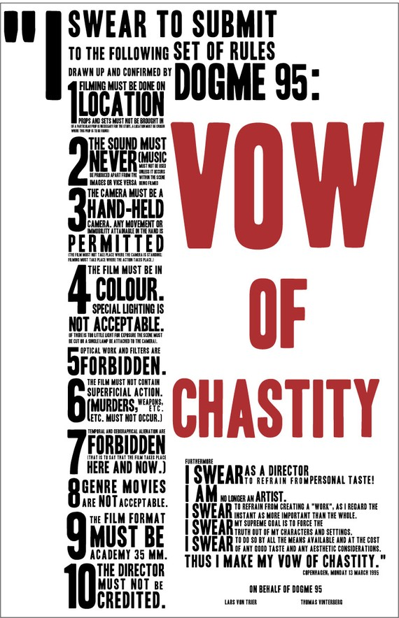
4. Manifestos come in many forms.
During the “second-wave” avant-garde of the 1960s, the manifesto experienced a major rebirth, becoming again part of the general atmosphere as it was in Europe before and after the First World War. One anthology, BAMN (By Any Means Necessary): Outlaw Manifestos and Ephemera, 1965-70 (1971), described some of the situations in which the manifesto might have appeared and the forms it might have taken:
Perhaps it caught your eye as a flyposter, nailed to a tree, published in a “now-you-see-it-now-you-don’t” magazine or news-sheet. It could have been incanted at a wedding service, passed round as trading cards, posted as a chain letter, read on a menu. It may even have whizzed past your head while wrapped round a brick.
The BAMN anthology provides some good examples from the heady late-'60s, including the “Outlaws of Amerika” trading card series. Created for the 1968 Democratic National Convention, the cards depict various members of the Black Panthers and “200,000 pot smokers” (a figure that sounds charmingly conservative today). Also from 1968 is a manifesto reportedly written by Salvador Dali and found “behind the barricades in Paris” —perhaps even wrapped around a brick and ready to be tossed at The Establishment.
Today the manifesto is experiencing a rebirth of a very different kind. With the proliferation of the Internet in the past decade, the manifesto has expanded into every corner of the arts (and crafts), as well as academia (e.g. “The Digital Humanities Manifesto 2.0”). But the most startling change is that the manifesto, which has long borrowed from advertising, has itself been coopted as a business-friendly genre. It has of late become tame, even cute: an untroubling, unironic, fully digested meme for the attention deficient.
The new wave of “inspirational” self-help manifestos—as if the vast majority of manifestos weren’t inspirational—demonstrates the malleability of the form. The recent boom shows no sign of ending. As one new guru of positivity and self-promotion, Alexandra Franzen, recently proclaimed: “It doesn’t matter if you’re a stay-at-home mama, a rising entrepreneur, an aspiring author, a CEO, or a preschool teacher—everyone needs a blow-your-mind manifesto. It’s just . . . necessary. And sexy.”
5. Manifestos are better very short than very long.
The longer a manifesto is, the exponentially crazier and duller it seems to get. If a manifesto is a type of advertisement, then ask yourself: Who would write a 35,000-word advertisement? The Unabomber, for one. Ted Kaczynski’s "Industrial Society and Its Future" (1995) is a classic of the extreme end of the genre. A too-long manifesto is, at the very least, something akin to an eight-hour speech by Fidel Castro. It is a marathon performance intended to impress by sheer excess. If you still need convincing, take a look at the endless cut-and-paste drivel of Norwegian mass murderer Anders Breivik’s "2083: A European Declaration of Independence" (2011) or, indeed, Adolf Hitler’s 700-page Mein Kampf (1925). These are not the examples most of us want to follow.
Better, obviously, is something like this: “A Short Manifesto” (1964) by the Dutch conceptual artist Stanley Brouwn. It ends with a vision of the future, in 4,000 AD:
NO MUSIC
NO THEATRE
NO ART
NO
THERE WILL BE SOUND
COLOR
LIGHT
SPACE
TIME
MOVEMENT
Or the “Laws of Sculptors” (1969), by the English artists Gilbert & George, written during the same decade of social upheaval but with a tone that rejected the surrounding chaos. In their manifesto, four concise, keep-calm-and-carry-on-style “laws” are laid out for fellow artists: “Always be smartly-dressed, well groomed relaxed and friendly polite and in complete control.”
6. Manifestos are theatrical.
When I first encountered the manifesto as an undergraduate I was lucky enough to see it as a living thing and not a thing of the past. This was thanks to my professor, a charismatic Romanian woman in her 40s who also happened to be a Neoist performance artist and manifesto writer—a real-life avant-garde provocateuse. The summer course she taught traced the radical avant-garde that descended from Futurism through Vorticism, Dada and Surrealism to Situationism and post-punk movements like Neoism.
In our daily meetings she revealed a degree of permissiveness that we had not heretofore encountered, even in our most liberal research seminars. One student, a theater major named Peter, declaimed his manifesto in the nude, which was uncomfortable given the restrictive confines of our basement classroom. He had scrawled the main tenets of his manifesto in Sharpie across his chest and limbs. He even wrote something down there, though none of us got close enough to read what it said. When Peter finished, our professor complimented him on his “excellent provocation” and his “Olympian” physique. He got an A.
Performance is part of the manifesto’s materiality, its existence in the world. Marinetti made art into a kind of Punch and Judy show, full of pantomime fisticuffs and bold, simple story lines: Destroy the past, embrace the future. From Dada manifestos in the Cabaret Voltaire in 1916 to the radical street theater of the 1960s to Lars von Trier’s scattering of red leaflets printed with his “Vow of Chastity” into the audience at a Paris cinema conference on the future of film in 1995, the manifesto—manu festus, “struck by hand”—has always been about striking gestures.
7. Manifestos are fiction dressed as fact.
Particularly in the preamble, manifestos are a kind of storytelling. The two most famous manifesto templates, The Communist Manifesto and “The Founding and Manifesto of Futurism,” begin as stories. The first opens with a ghost story (“A specter is haunting Europe”), the second is a tale of how the manifesto was written (“blackening reams of paper with our frenzied scribbling”) and how the movement was founded. The engaging origin narrative of Futurism includes a car chase (in 1909!) that ends with Marinetti crashing into a ditch and being hauled out by a group of fishermen. From that very spot, “faces smeared with factory muck,” their incendiary manifesto was proclaimed to Italy and the world.

8. Manifestos embrace paradox.
Fleeting and permanent, serious and ridiculous, sincere and ironic, always undermining their own authority, manifestos are unstable texts in the extreme. The bluster and bravado of any Futurist manifesto is at once self-parody and serious polemic. Its roots are traceable to influences like Nietzsche, Sorel, and Whitman, but also to the paradoxes of late-Victorian dandies and aesthetes like James McNeill Whistler and Oscar Wilde. Wilde, so fabulously flippant and ironic in his art, gravely pursued his aesthetic and moral beliefs to his death.

9. Manifestos are always on the bleeding edge.
Make it new: In our age of ever-shortening texts, this dictum of Ezra Pound remains likely the shortest manifesto ever written, and its message is still vital. In 1909 the Futurists refused reverence and predicted, even begged for their overthrow by the next generation: “Younger and stronger men will throw us in the wastebasket like useless manuscripts,” they cried. “We want it to happen!” Like all good manifestos, they built in their own obsolescence, clearing the way for the next vision of the future.

10. Manifestos are magic (almost).
The last century is littered with manifestos full of failed dreams and dreams that turned into nightmares, but some manifestos mark the beginning of a path to realization. Most manifestos are written from the point of view of disillusionment struggling back to hope—“hope not being hope,” as Marianne Moore’s poem “The Hero” (1932) states, “until all ground from hope has vanished.” Think of Shepard Fairey’s Hope poster for Barack Obama’s 2008 campaign: Whatever the reality, this poster’s single-word manifesto brought magic back to politics after years of disillusionment. It summed up a platform and made a promise. It energized a voting public that wanted to believe that there was something more than business as usual.
Manifestos are repositories of a kind of magic and madness that does not exist in any other genre. Take for example the Zaoum poets who were an offshoot of Russian Futurism. If the Italian Futurists were bold and brash and stylish, the Russian Futurists (who cross-pollinated with Russian Formalists like Roman Jakobson) were mad geniuses and magicians with language. One Zaoum manifesto, “The Trumpet of the Martians” (1916) by Victor Khlebnikov, announces as if in the voice of a character from science fiction: “People of Earth, hear this!”
Michael Jackson wrote a manifesto, which 60 Minutes discovered and aired in 2013. In 1979 MJ laid out plans for his rebranding and subsequent world domination (“MJ will be my new name”). In its highest form, the manifesto acts as a magic spell incanted by the visionary artist. It is a performative speech/act that attempts to bring a new reality into existence. MJ’s most significant line is, “I will be magic.”
Manifesto writers over the past century have tried, above all—to paraphrase Marinetti (and Wilde)—to hurl their hopes at the stars while lying in the muddy water of modernity’s ditch.
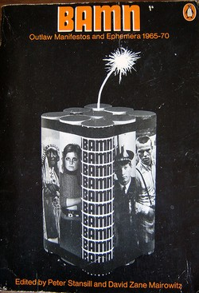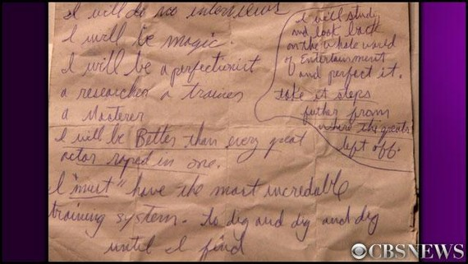

The intention of this assignment, your personal manifesto, is to reflect on all that you have learned through this course and apply your knowledge to create a protest manifesto reflecting action you believe to be necessary in your own environment. You will also want to consider how the history and context of your area or cause can fuel your manifesto and determine your medium.
Instructions: Now it is time for you to think about your current time and place and create a manifesto of protest. Think about the injustices plaguing your area, the people you know and care about, or yourself and create a manifesto outlining your hopes, pledges and/or demands for change. You may include an image, a musical piece, an extract from a play and/or anything else material/immaterial alongside your text. You may also choose to simple compose a ‘List’ for your manifesto.
Manifesto: A Call to Action. A manifesto is a public statement stating your views or your intention to do something. A manifesto advances a set of ideas, opinions, or views, but it can also lay out a plan of action. While it can address any topic, it most often concerns art, literature, or politics. Manifestos are generally written in the name of a group sharing a common perspective, ideology, or purpose rather than in the name of a single individual.
Your Manifesto must be accompanied by a Critical Report (maximum 1 page long) analysing the reasons behind choosing this subject to protest about, i.e., the justifications. You may also discuss challenges you faced or problems you had to ‘resolve’. You should be able to convince the class as to why this is a serious social injustice. It must be submitted within 24 hours of presenting your Manifesto to class, along with the Manifesto itself on eclass (only).

Οδηγίες: Τώρα είναι καιρός να σκεφτείτε την τρέχουσα ώρα και τον τόπο σας και να δημιουργήσετε ένα μανιφέστο διαμαρτυρίας. Σκεφτείτε τις αδικίες που μαστίζουν την περιοχή σας, τους ανθρώπους που γνωρίζετε και ενδιαφέρεστε ή τον εαυτό σας και δημιουργήστε ένα μανιφέστο που περιγράφει τις ελπίδες, τις δεσμεύσεις ή/και τις απαιτήσεις σας για αλλαγή. Μπορείτε να συμπεριλάβετε μια εικόνα, ένα μουσικό κομμάτι, ένα απόσπασμα από ένα θεατρικό έργο ή/και οτιδήποτε άλλο υλικό/άυλο μαζί με το κείμενό σας. Μπορείτε επίσης να επιλέξετε να συνθέσετε απλά μια «Λίστα» για το μανιφέστο σας.

Updates and Revisions to the Top Ten Famous Manifestos
- The Bible and the Ten Commandments (1)
- The US Declaration of Independence (2)
- Martin Luther King’s I Have a Dream speech (3)
- Marx and Engel’s The Communist Manifesto (4)
- Apple Ad – Here’s to the Crazy Ones (10)
- Andre Breton’s Surrealist Manifesto (Replaced)
- John F Kennedy’s Land a Man on the Moon speech (8)
- Russell – Einstein Manifesto to question the use of Nuclear Weapons (Replaced)
- Lock, Searls, Weinberger and Levine’s The Cluetrain Manifesto (Replaced)
- Fond and Hopper, Easy Rider movie (Replaced)
Ted Kaczynski’s Unabomber manifesto was added to this list as a bonus manifesto in 2021 – it now sits at #5.
New additions to this list are:
- Marinetti’s Futurism Manifesto (7)
- Charles Darwin’s On the Origin of Species (6)
- The UN Universal Declaration of Human Rights (9)

More famous manifestos
If you want more examples of famous manifestos to add to your discussion, I’ve collected over 260 examples at 1000manifestos.com
Plus, here are three recent blog posts and videos on Manifestos that may be of interest:
- Content Creation Manifesto – The Ultimate Guide to Thought Leadership Content
- Thought Leadership Content – What is a Manifesto?
- Three big reasons to write a thought leader manifesto
Which examples would you add to this list? What are your most famous manifestos?
The Holstee Manifesto
Holstee’s Manifesto for Change - Mindful

More “Classic” Manifestos
https://geoffmcdonald.com/famous-manifestos/

FEMEN

