Ασκ_1
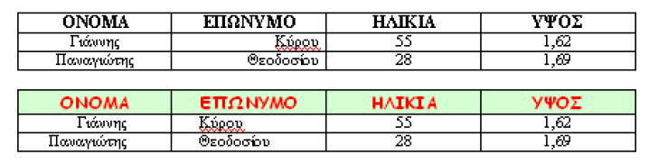
Ασκ_4

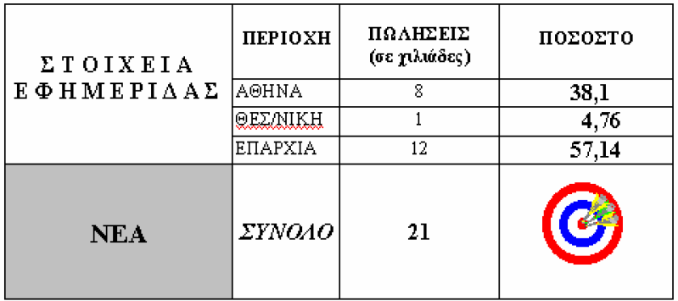

Ασκ_2

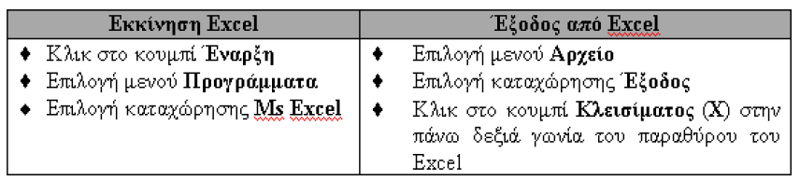

Ασκ_7

