Nodal Analysis
Nodal analysis is the application of Kirchoff's Current Law (KCL) to solve for the voltages at each node in an equation. A node voltage is defined as the potential difference between the given node and a designed reference node (ground). Since one node is defined as ground, a circuit with N nodes will require N-1 equations to solve completely.
If all sources are current sources, all N-1 equations will be KCL equations: The sum of the current into the node is equal to the sum of the current out of the node. Currents not connected to current sources can be found using:
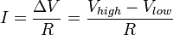.
Given M voltage sources (for M less than or equal to N-1), there will be M KVL equations and (N-1)-M KCL equations. A supernode may be formed if necessary.

Steps
- Identify the nodes. These are places where one device ends and another begins (i.e. a wire connects to a resistor).
- Choose one node to be the reference node, and identify it with a ground symbol. Nodes which connect to multiple other nodes, or which are near a voltage source are the easiest.
- Label all the nodes, usually written as V_n, where n is the number of the node
- Use Kirchoff's Current Law to set up an equation for each node. This will leave you with a System of Equations.
- Solve the System of Equations for each unknown variable

Example
Given the Circuit below, find the voltages at all nodes.
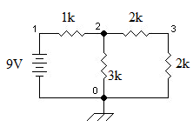
example circuit for nodal analysis example.
- node 0: (defined as ground node)
- node 1: (free node voltage)
- node 2: 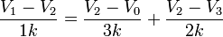
- node 3: 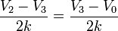
which results in the following system of linear equations:
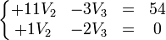
Therefore, the solution is:
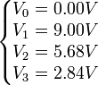

Mesh Current Analysis
Mesh analysis is the application of Kirchoff's Voltage Law (KVL) to solve for mesh currents. A mesh current is defined as the current in a mesh: a loop not containing any other loops. For M meshes, there will be M equations.
If all sources are voltage sources, all M equations will be KVL.
If the circuit has N current sources, there will be N KCLs and M-N KVLs.
Mesh analysis is often easier as it requires fewer unknowns; however, it can only be used on planar circuits.

Example
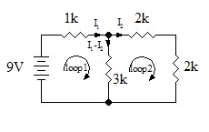
Circuit diagram for use with the Mesh Current example problem.
The circuit has 2 loops indicated on the diagram. Using KVL we get:
- Loop1:
- Loop2:

Simplifying we get the simultaneous equations:
Solving to get:

Nodal Analysis of Electric Circuits
In this method, we set up and solve a system of equations in which the unknowns are the voltages at the principal nodes of the circuit. From these nodal voltages the currents in the various branches of the circuit are easily determined.
The steps in the nodal analysis method are:
- Count the number of principal nodes or junctions in the circuit. Call this number n. (A principal node or junction is a point where 3 or more branches join. We will indicate them in a circuit diagram with a red dot. Note that if a branch contains no voltage sources or loads then that entire branch can be considered to be one node.)
- Number the nodes N₁, N₂, . . . , N_{n} and draw them on the circuit diagram. Call the voltages at these nodes V₁, V₂, . . . , V_{n}, respectively.
- Choose one of the nodes to be the reference node or ground and assign it a voltage of zero.
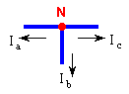
  - For each node except the reference node write down Kirchoff's Current Law in the form "the algebraic sum of the currents flowing out of a node equals zero". (By algebraic sum we mean that a current flowing into a node is to be considered a negative current flowing out of the node.)
For example, for the node to the right KCL yields
the equation:
I_{a} + I_{b} + I_{c} = 0
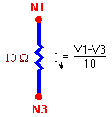
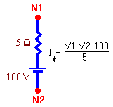
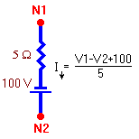
Express the current in each branch in terms of the nodal voltages at each end of the branch using Ohm's Law (I = V / R). Here are some examples:
The current downward out of node 1 depends on the voltage difference V1 - V3 and the resistance in the branch.
In this case the voltage difference across the resistance is V1 - V2 minus the voltage across the voltage source. Thus the downward current is as shown.
In this case the voltage difference across the resistance must be 100 volts greater than the difference V1 - V2. Thus the downward current is as shown.
The result, after simplification, is a system of m linear equations in the m unknown nodal voltages (where m is one less than the number of nodes; m = n - 1). The equations are of this form:
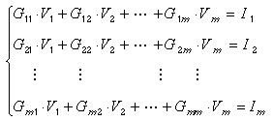
where G₁₁, G₁₂, . . . , G_{mm} and I₁, I₂, . . . , I_{m} are constants.
Alternatively, the system of equations can be gotten (already in simplified form) by using the inspection method.
- Solve the system of equations for the m node voltages V₁, V₂, . . . , V_{m} using Gaussian elimination or some other method.

Example 1: Use nodal analysis to find the voltage at each node of this circuit.

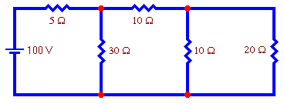

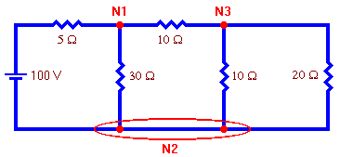
Solution:
- Note that the "pair of nodes" at the bottom is actually 1 extended node. Thus the number of nodes is 3.
- We will number the nodes as shown to the right.
- We will choose node 2 as the reference node and assign it a voltage of zero.
- Write down Kirchoff's Current Law for each node. Call V₁ the voltage at node 1, V₃ the voltage at node 3, and remember that V₂ = 0. The result is the following system of equations:
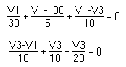
The first equation results from KCL applied at node 1 and the second equation results from KCL applied at node 3. Collecting terms this becomes:
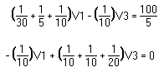
This form for the system of equations could have been gotten immediately by using the inspection method.
- Solving the system of equations using Gaussian elimination or some other method gives the following voltages:
V₁=68.2 volts and V₃=27.3 volts

Example 2: Use nodal analysis to find the voltage at each node of this circuit.

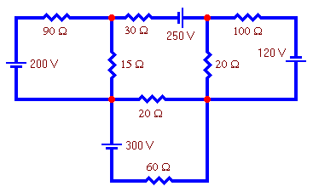

• We will choose node 2 as the reference node and assign it a voltage of zero.
• Write down Kirchoff's Current Law for each node. Call V₁ the voltage at node 1, V₃ the voltage at node 3, V₄ the voltage at node 4, and remember that V₂ = 0. The result is the following system of equations:
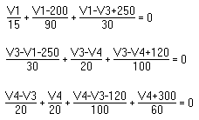
The first equation results from KCL applied at node 1, the second equation results from KCL applied at node 3 and the third equation results from KCL applied at node 4. Collecting terms this becomes:
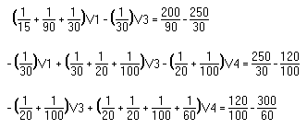
This form for the system of equations could have been gotten immediately by using the inspection method.
• Solving the system of equations using Gaussian elimination or some other method gives the following voltages:
V₁ = -35.88 volts, V₃ = 63.74 volts and V₄ = 0.19 volts

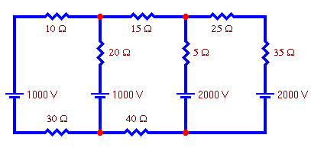
Example 3: Use nodal analysis to find the voltage at each node of this circuit.
Solution:

• The number of nodes is 4.
• We will number the nodes as shown to the right.
• We will choose node 4 as the reference node and assign it a voltage of zero.
• Write down Kirchoff's Current Law for each node. Call V₁ the voltage at node 1, V₂ the voltage at node 2, V₃ the voltage at node 3, and remember that V₄ = 0. The result is the following system of equations:
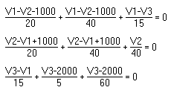
The first equation results from KCL applied at node 1, the second equation results from KCL applied at node 2 and the third equation results from KCL applied at node 3. Collecting terms this becomes:
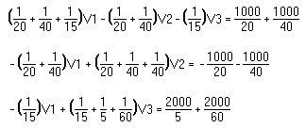
This form for the system of equations could have been gotten immediately by using the inspection method.
• Solving the system of equations using Gaussian elimination or some other method gives the following voltages:
V₁ = 1731 volts, V₂ = 548 volts and V₃ = 1937 volts

