- Skip to Main Content
By continuing to browse this site, you agree to its use of cookies as described in our Cookie Policy.×
Search within
•

Search term

Login / Register

Dyslexia

Edited By: Dr J B Talcott
Impact factor:1.568
ISI Journal Citation Reports © Ranking: 2018:16/41 (Education, Special)31/59 (Psychology, Educational)25/69 (Rehabilitation (Social Science))
Online ISSN:1099-0909
© John Wiley & Sons Ltd
- 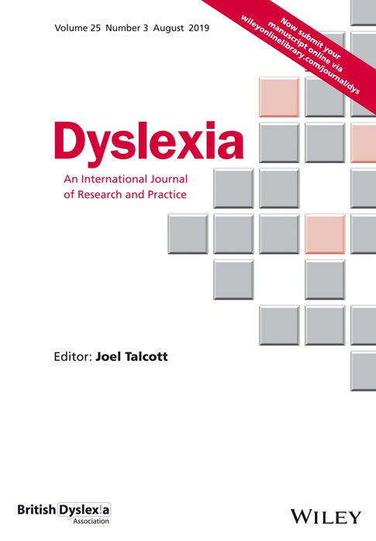
LATEST ISSUE >
Volume 25, Issue 3
August 2019

Navigation Bar

Menu
- Home
- About
- Contribute
- Browse

Follow journal
- Alert
- RSS Feeds

Articles
- Most Recent
- Most Cited
- The following is a list of the most cited articles based on citations published in the last three years, according to CrossRef.

The magnocellular theory of developmental dyslexia

  - John Stein
  - Pages: 12-36
  - First Published: 27 March 2001
  - Abstract
  - PDF
  - References
  - Request permissions

Executive functions in children with dyslexia

  - Astrid Reiter
  - Oliver Tucha
  - Klaus W. Lange
  - Pages: 116-131
  - First Published: 22 December 2004
  - Abstract
  - PDF
  - References
  - Request permissions

The cognitive deficits responsible for developmental dyslexia: Review of evidence for a selective visual attentional disorder

  - Sylviane Valdois
  - Marie‐Line Bosse
  - Marie‐Josèphe Tainturier
  - Pages: 339-363
  - First Published: 26 October 2004
  - Abstract
  - PDF
  - References
  - Request permissions

Molecular Genetics of Dyslexia: An Overview

  - Amaia Carrion‐Castillo
  - Barbara Franke
  - Simon E. Fisher
  - Pages: 214-240
  - First Published: 17 October 2013
  - Abstract
  - Full text
  - PDF
  - References
  - Request permissions

From language to reading and dyslexia1

  - Margaret J. Snowling
  - Pages: 37-46
  - First Published: 27 March 2001
  - Abstract
  - PDF
  - References
  - Request permissions
more >

Recent issues
- 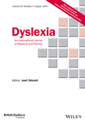
Volume 25, Issue 3
Pages: 225-331
August 2019
- 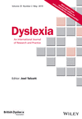
Volume 25, Issue 2
Pages: 113-224
May 2019
- 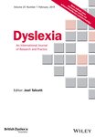
Volume 25, Issue 1
Pages: 1-112
February 2019
- 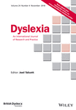
Volume 24, Issue 4
Pages: 307-400
November 2018
- Submit an Article
- Browse free sample issue
- Get content alerts
- Subscribe to this journal

More from this journal

Additional links

About Wiley Online Library
- Privacy Policy
- Terms of Use
- Cookies
- Accessibility

Help & Support
- Contact Us

Opportunities
- Subscription Agents
- Advertisers & Corporate Partners

Connect with Wiley
- The Wiley Network
- Wiley Press Room
Copyright © 1999-2019 John Wiley & Sons, Inc. All rights reserved

